**EXERCISES AND DIAGRAMS** (you can complete these exercises whilst watching TV during the ad breaks or whenever you have a spare few minutes)

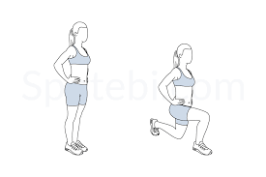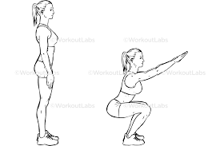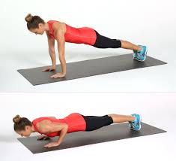**1 Push-ups** **3** **Air** **Squats** **5** **Lunges**

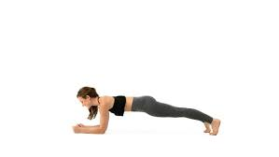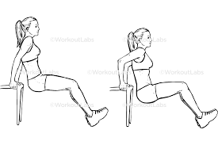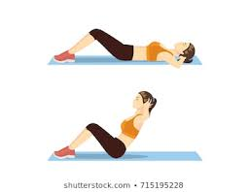**2 Sit-ups** **4** **Dips on a chair** **6** **Plank/ Bridge**

**EXERCISES AND DIAGRAMS** (you can complete these exercises whilst watching TV during the ad breaks or whenever you have a spare few minutes)

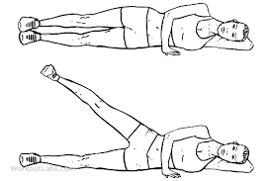**7 Side Leg Raises 9 Step-ups 11 Star Jumps**

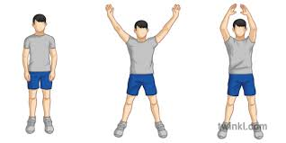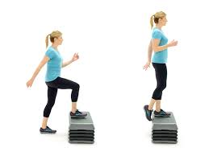

[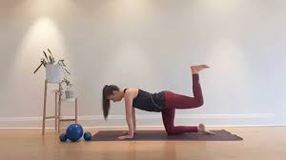](https://www.google.com.au/imgres?imgurl=https%3A%2F%2Fthekerryhemingway.com%2Fwp-content%2Fuploads%2F2018%2F11%2Fedited-hammy-830x464.png&imgrefurl=https%3A%2F%2Fthekerryhemingway.com%2Ftag%2Fhamstring-exercise%2F&tbnid=uEBPoXpMxZRJOM&vet=10CCUQMyh2ahcKEwiwnZ7OurnoAhUAAAAAHQAAAAAQAg..i&docid=3AKuZXUWdYdz9M&w=830&h=464&q=hamstring%20lifts%20picture&hl=en&safe=strict&ved=0CCUQMyh2ahcKEwiwnZ7OurnoAhUAAAAAHQAAAAAQAg)**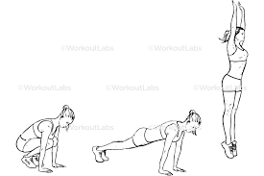8 Hamstring Lifts 10 Wall Squats 12 Burpees**

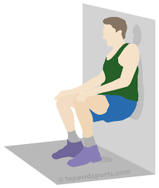

**EXERCISES AND DIAGRAMS** (you can complete these exercises whilst watching TV during the ad breaks or whenever you have a spare few minutes)

[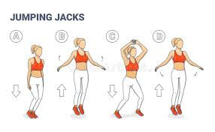](https://www.google.com.au/imgres?imgurl=https%3A%2F%2Fthumbs.dreamstime.com%2Fb%2Fgirl-doing-jumping-jacks-exercise-workout-silhouettes-star-jumps-illustration-young-woman-sportswear-top-leggings-170972100.jpg&imgrefurl=https%3A%2F%2Fwww.dreamstime.com%2Fillustration%2Fjumping-jacks.html&tbnid=r8XC2zndjZLYUM&vet=12ahUKEwihsMaC27noAhXDFrcAHewyB0QQMygVegQIARBA..i&docid=DasCiO9IKv3LlM&w=800&h=492&q=jumping%20jacks%20picture&hl=en&safe=strict&ved=2ahUKEwihsMaC27noAhXDFrcAHewyB0QQMygVegQIARBA)**13 15 Jogging on the Spot 17 Bicep Curls (need weights)**

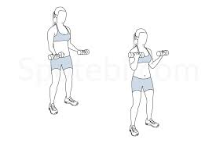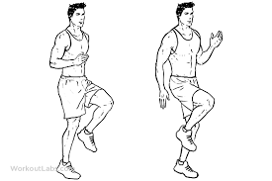

[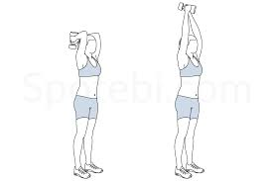](https://www.google.com.au/imgres?imgurl=https%3A%2F%2Fwww.cdn.spotebi.com%2Fwp-content%2Fuploads%2F2014%2F10%2Fdumbbell-triceps-extension-exercise-illustration.jpg&imgrefurl=https%3A%2F%2Fwww.spotebi.com%2Fexercise-guide%2Fdumbbell-triceps-extension%2F&tbnid=KU2krzCnbPnQvM&vet=12ahUKEwil_77N67noAhUvDbcAHZfIDpEQMygaegQIARBl..i&docid=QVxwV0uqZcgeaM&w=1080&h=720&q=tricep%20extensions%20picture&hl=en&safe=strict&ved=2ahUKEwil_77N67noAhUvDbcAHZfIDpEQMygaegQIARBl)**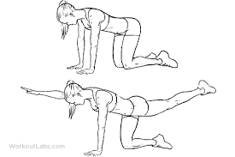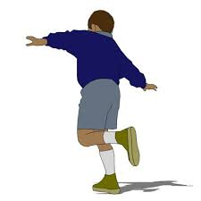14 Hopping on the Spot 16 Opposite Arm and Opposite Leg Lifts Tricep Extensions (need weights)**

**EXERCISES AND DIAGRAMS** (you can complete these exercises whilst watching TV during the ad breaks or whenever you have a spare few minutes)

**Shoulder Press (need weights)**

