www.schoolsrecycle.planetark.org
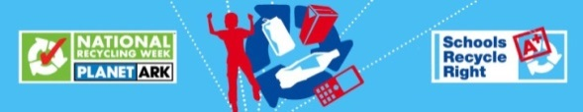
http://www.cleanup.org.au/au/
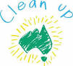
http://www.olliesworld.com/
http://www.terracycle.com.au/en-AU/
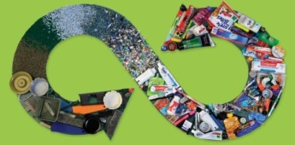
http://www.more4kids.info/704/top-10-recycling-websites-for-kids/
http://www.rethinkrecycling.com/learn-educate/resources-topic/games-and-activities
http://www.kindergarten-lessons.com/recycling_for_kids/
http://www.colormegood.com/holidays/earthdayrecycling.html
http://www.sciencekids.co.nz/recycling.html
www.recycool.org
www.recylingconsortium.org.uk
www.eastleigh.co.uk/ebc
www.recycling-guide.org.uk/schools
www.recyling-more.co.uk
www.bbc.co.uk/schools/barnabybear/games/recycle
www.recycle.com

Recycling and Upcycling activities for early years
http://www.education.com/activity/article/recycling-tree/http://www.education.com/activity/article/Making_Compost/
http://www.education.com/activity/article/Bin_Worms_Dessert/
http://www.education.com/activity/article/make_a_worm_hotel_kinder/
http://www.education.com/slideshow/recycle-it/milk-carton-train/
http://www.education.com/slideshow/recycle-it/pirate-hook/
http://www.education.com/slideshow/recycle-it/creature-sock-sculpture/
http://www.education.com/slideshow/recycle-it/make_a_gilded_sneaker_planter/
http://www.education.com/slideshow/egg-carton-activities/Egg-cellent_Counting_Game/
http://www.education.com/slideshow/green-crafts-kindergarten/pinecone_bird_feeder_kindergarten/
http://www.education.com/slideshow/recycle-it/toilet-paper-roll-maracas/
http://www.education.com/slideshow/egg-carton-activities/create-egg-carton-mask/
http://www.education.com/slideshow/egg-carton-activities/egg-carton-shake/
http://www.education.com/slideshow/green-crafts-kindergarten/balloon-greenhouse/
http://www.education.com/slideshow/green-crafts-kindergarten/Rainboot_Planters/
http://www.education.com/slideshow/green-crafts-kindergarten/Soda_Bottle_Greenhouse/
http://www.education.com/slideshow/recycle-it/milk_carton_math/
http://www.education.com/slideshow/egg-carton-activities/Egg_Cup_Flowers/
http://www.education.com/slideshow/green-crafts-kindergarten/recycled-multimedia-collage/
http://www.education.com/slideshow/recycle-it/cup-photo-holder/
http://www.education.com/slideshow/egg-carton-activities/create-school-bus/
http://www.education.com/slideshow/recycle-it/100th-day-of-school-sculpture/
http://www.education.com/slideshow/egg-carton-activities/ping-pong-patterns/
http://www.education.com/slideshow/green-crafts-kindergarten/Make_your_own_paintbrushes/
http://www.education.com/slideshow/recycle-it/blue-jean-pocket-purse/
http://www.education.com/slideshow/egg-carton-activities/egg-carton-color-sorter/
http://www.education.com/slideshow/green-crafts-kindergarten/egg-carton-daffodils/
http://www.education.com/slideshow/egg-carton-activities/egg-carton-spiders/
http://www.education.com/slideshow/recycle-it/cardboard-tube-critters/
http://www.education.com/slideshow/egg-carton-activities/egg-carton-caterpillar/
http://www.education.com/slideshow/recycle-it/cereal-box-house/
http://www.education.com/slideshow/egg-carton-activities/hanukkah-countdown-calendar/
http://www.education.com/slideshow/recycle-it/Coffee_Can_Stilts/

Recycling Peppa Pig- https://www.youtube.com/watch?v=oxeo_whmOC0
How recycling Works- https://www.youtube.com/watch?v=VlRVPum9cp4
How does recycling really work- https://www.youtube.com/watch?v=b7GMpjx2jDQ
Home Recycling- https://www.youtube.com/channel/UCRzL59__U39n0BbUNnK0RCw

