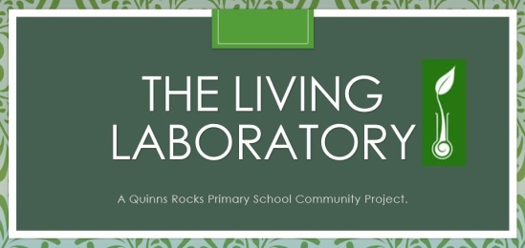

Quinns Rocks Primary School Community Garden Risk Assessment

(For detailed descriptions of likelihood and consequence levels, see the end of this document)
IDENTIFIED RISK | CONSEQUENCES | LIKELI-HOOD | OVERALL RISK LEVEL | MITIGATION/CONTROL MEASURES
Sharp cutting equipment:eg. Saws, shovels, power tools, secateurs, hedge trimmers. | Major: Cuts, deep wounds, broken bones | Possible | High | - Safety check activity incorporated into sign on sheet.  - First Aid kit available at site  - Under 18s not to use power cutting tools  - Members using power tools MUST wear enclosed shoes, long sleeved shirt, long trousers and eye protection.  - Safety goggles provided in shed.  - Annual maintenance schedule for power tools to ensure they are in good working order.
Pointed gardening tools: e.g. crowbars, pitch forks | Major: Deep wounds | Likely | High | - Safety check activity incorporated into sign on sheet  - Age-appropriate training provided for all Under 18s in safe use of gardening tools.  - First Aid kit available at site  - Active children encouraged to play away from main garden area  - Annual maintenance of garden tools (e.g. check mattock heads)
Trip hazards | Major: Sprains, broken bones | Likely | High | - Safety check activity incorporated into sign on sheet  - First Aid kit available at site  - Members encouraged to store tools so that they cannot be tripped over  - Active children encouraged to play away from main garden area  - All gardening members must wear enclosed shoes when on site.
Sun, heat | Moderate: Sunstroke; dehydration | likely | High | - Encourage wearing of hats  - Provide 30+ sun cream protection  - Water available on site  - Shaded areas available for all students
Falling tree branches | Major: Broken bones; concussion | Rare | Medium | - Annual check for unsafe branches
Uneven ground, holes | Major: Sprains; broken bones | Possible | Medium | - Members encouraged to barricade and/or fill in holes  - Use warning tape
Stings and bites – insects, spiders, ants | Minor: Swelling; pain; itching | likely | Medium | - First aid kit available at site
Inhalation of potting/ compost mixes | Major: Legionnaires disease | Rare | Medium | - Masks available in shed
Inappropriate conduct towards children and young people by garden visitors or other members of the public. | Major: Safety and wellbeing of children compromised/child abuse | Rare | low | - Warning parents of children that this area is not policed by the school and the public have ready access.  - Parents encouraged to supervise children at regular garden activities.  - Protective behaviours eg staying in sight, going to toilet in pairs/groups, checking with parents before leaving ‘line of sight’ area encouraged and promoted by garden members.
Recreational hazards: cyclists; soccer games,  running | Moderate: Injury from collision | Unlikely | Low | - Advising public and local residents of timing of garden activities and events  - Advising members of the multi-functional nature of the area  - Don’t run around the area always walk
Dogs off leash | Moderate: Bites, mauls | Unlikely | Low | - Advising members to stay away from dogs off leash.  - Any problem dogs to be reported to owners, and if necessary, City Council.
Gardening equipment | Insignificant: Cuts, blisters, abrasions, chaffing | Possible | Low | - Safety check with sign on sheet  - Encourage wearing of gloves
Vehicles | Major: Collision, injury to pedestrians/passers by from a slow-moving vehicle in the garden collection lane and access way. | Rare | Low | - Vehicular access padlocked and entry of vehicles to garden area minimised  - Vehicles must move at slow pace 10kph

More information about risk rating system used.
Consequence: What harm could happen as a result of the identified risk?
Descriptor | Examples
Insignificant | Injuries not requiring first aid
Minor | First aid required
Moderate | Medical treatment required
Major | Hospital admission required
Severe | Death or permanent disability to one or more persons

Likelihood: What is the likelihood of the determined consequence occurring?
Descriptor | Examples
Almost certain | Is expected to occur in most circumstances
Likely | Will probably occur in most circumstances
Possible | Could occur at some time
Unlikely | Not likely to occur in normal circumstances
Rare | May occur only in exceptional circumstances

Risk levels matrix
Likelihood | Consequences
 | Insignificant | Minor | Moderate | Major | Severe
Rare | Low | Low | Medium | Medium | Medium
Unlikely | Low | Low | Medium | Medium | High
Possible | Low | Medium | High | High | Very high
Likely | Medium | Medium | High | High | Very high
Almost certain | Medium | High | High | Very high | Very high

Recommended action
Very high: Act immediately to lower the risk level to as low as reasonably practicable.
High: Act today to reduce the risk.
Medium: Act this week
Low: Act this month

