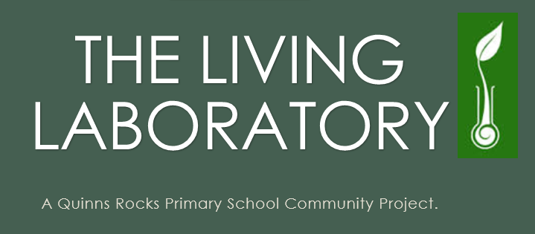

What is “The Living Laboratory”

The Living Laboratory will create a beautiful and natural wonderland which showcases and demonstrates the future and wonder of food ~ from the soil up to our plates and then back again. It aims to provide inspiration and know-how for the next generation of youth and the regeneration of local communities.

*Let’s enhance children's love of learning, healthy food, and nature through garden-based education.*

*Reasons to create a living classroom for our children.*

1. **Environmental Ownership**

A school garden is a powerful environmental education tool. Through gardening, students become responsible caretakers. They have an opportunity to engage in agricultural practices on a small scale, learning about the responsibilities and impacts of land cultivation. They explore the web of interactions among the living and nonliving players that sustain life. By doing so, they develop a greater understanding of the natural world.

1. **Community and Social Development**

Community and social development lessons do not receive the attention of academic achievement, but they are as crucial to the survival of our country as reading and writing. Children must learn how to take responsibility for their environment and develop a strong sense of community to ensure the continuation of our society.

Gardens create opportunities for students to work cooperatively and to take on responsibilities. They will quickly learn the negative consequences associated with forgetting to water their plants on a hot day and will work hard to make sure it does not happen again. The plants will also provide positive reinforcement in response to proper care by growing or producing fruits, contributing to development of a good work ethic. On a personal level, gardening builds confidence, self-esteem, and pride as the student’s watch their efforts turn into beautiful and productive gardens. It also teaches them patience as they wait for a seedling to sprout or a tomato to ripen.

Above all, gardening is fun and is a skill that, once acquired, can be a lifelong hobby. Spending time outside, exploring in the soil, watching seeds grow, and harvesting the bounty can be enjoyable and memorable ways for students to spend their time.

1. **A Healthy Lifestyle**

Beyond academics, the garden provides broader life lessons including contributing to students’ knowledge of how to maintain a healthy lifestyle. The state of California is experiencing a major health crisis as the number of overweight and obese youth is growing at an epidemic rate. Approximately one in three children is overweight or at risk of being overweight, and almost 40 percent of school-aged children are considered unfit. The number of weight-related chronic diseases such as diabetes is of great concern to health care professionals, and the need for prevention education is critical.

Garden programs work to combat this epidemic by teaching youth about healthy lifestyles including proper nutrition and physical activity. Through a gardening program, students gain firsthand experience with fresh fruits and vegetables. They discover that produce does not magically appear on the grocery store shelves and learn about the important role of agriculture in our society. The pride and curiosity sparked by growing the fruits and vegetables along with the familiarity of where they come from motivates students to try them, often times leading to more positive attitudes and eating behaviours. A garden program increases produce availability and creates opportunities to teach students what they should eat through fun, hands-on experiences.

A healthy lifestyle is more than just eating right, though. Students also need to adopt good exercise habits. The garden provides a wide range of physical activity through digging, planting and weeding. The garden activities are often so captivating that students will not even realize they are exercising. Plus, it is an activity they can participate in for the rest of their lives.

1. **Academic Achievement**

A school garden is a perfect tool to provide hands-on learning experiences for any academic subject. Science is the most common subject linked to gardens. Many teachers use the garden as a laboratory to introduce students to scientific methods through plant-related experiments. Additionally, a garden provides a place to study weather, insects, soil and other environmental topics. It’s the ideal habitat model for studying ecosystems. The real-life experiences contribute greatly to students’ comprehension and retention of new science knowledge, a fact supported by studies linking participation in a gardening program to increases in science achievement scores.

In addition to science, the garden provides opportunities to teach mathematics, history-social science, English language arts, and visual and performing arts. Concepts that seem abstract in the classroom come alive in a garden setting. For instance, students find taking daily measurements of garden bean plants and then charting the growth rate to determine the fastest growing plant in the garden much more exciting than charting numbers provided by a textbook.

*So we have 660sqm of land to convert into this wonderful concept for our community.*

*Consider being part of our exciting project and contact us today on (08) 9305 1500 to find out how you can support our school in creating A Living Laboratory.*

Create a whole school approach.

Committee formed-Principal-Project leader- Interested teachers- parents- students.

*Create a Logo / Presence for your project.*

*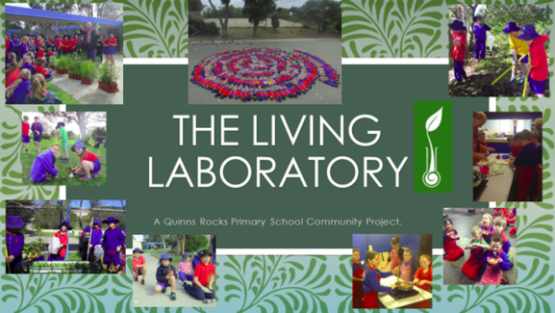 You are now easily recognisable.*

*We ran a garden design competition.*

*Winning Garden design follows.*

**

Create a whole school approach.

Meetings run approximately once a month.

Newsletters sent out with school newsletter, once a month.

<http://enterprisingkidz.weebly.com/monthly-newsletters.html>

Apply for funding-

Bankwest Up to $1000

Wanneroo Shire $3000

Teachers Mutual Bank-Up to $1500

Waste Wise Round 1 $2200 2 $4400 3 $8800

IGA- Community Chest $???

Tamala Park MRC-In kind donations $500

Suez $$???

Landcare $1500

P&C $???

Bunnings in-kind donations.

Cost the project????

Facilitate project build.

<http://enterprisingkidz.weebly.com/living-laboratory-gallery.html>

Create a whole school approach.

Each class collects materials for recycling.

Each class collects food scraps for the worms.

Start composting

Incursions – Peg Davies

Setting up a worm farm

Setting up composters.

Bunnings Micro bat boxes.

Bird nest boxes.

Excursions- Kiara Farm School.

Tamala Park

Wanneroo Shire-Recycled Christmas trees.

Wakakiri

Get help from the community

TAFE are great at helping.

So are the parents and local business owners.

Start your build. Be prepared for a fairly long process. Building takes ages especially when children are involved.